Optimization of CPU Core Processing for
High Data Rate QPSK Communication

1. Introduction
- High data rate communication requires significant computational resources.
- GNU Radio flowgraphs contain multiple DSP blocks that process samples in real time.
- Efficient CPU utilization is necessary to avoid processing bottlenecks.

2. Existing Challenge
- Limited CPU core utilization.
- Some blocks became processing bottlenecks.
- Higher sample rates increased computational load.
- Possibility of buffer overflow and dropped samples.
- System initially used a USB 2.0 connection.

Problem Faced
During high data-rate operation, the GNU Radio flowgraph experienced:
- Underflow issues
- Bandwidth limitations
- Sample rate mismatches
- Reduced system stability

3. CPU Intensive Blocks
The following blocks were identified as the major contributors to processing load:
- USRP Source
- Symbol Synchronization
- Costas Loop
- QPSK Demodulator
- Frame Extractor
- Phase Resolver

4. USB 3.0 Configuration
- The SDR was connected through a USB 3.0 port.

Benefits
- Higher data transfer rate
- Continuous sample streaming
- Reduced packet loss
- Improved real-time performance

USB 2.0 vs USB 3.0 — Comparison
Feature | USB 2.0 | USB 3.0
Release Year | 2000 | 2008
Maximum Data Transfer Rate | 480 Mbps (0.48 Gbps) | 5 Gbps
Real-World Speed (Typical) | 30–40 MB/s | 350–450 MB/s
Bus Bandwidth | 480 Mbps | 5 Gbps
Duplex Mode | Half-Duplex | Full-Duplex
Number of Data Lanes | 1 | 2 (SuperSpeed lanes)
Power Supply | 5V, up to 500 mA | 5V, up to 900 mA
Connector Color | Black | Blue
Cable Wires | 4 wires | 9 wires
Backward Compatibility | N/A | Yes (works with USB 2.0 devices)
Forward Compatibility | No | N/A
Use Cases | Keyboards, mice, printers, basic storage, low-speed peripherals | External HDD/SSD, high-speed storage, video capture, large file transfer, SDR devices
Example in SDR (USRP) | Suitable for low sample rates (≤ 5–10 MSPS) | Required for higher sample rates (≥ 10–50 MSPS and above)

In brief: this section covers the fix for the I/O side — moving to USB 3.0 removed the transfer-rate ceiling that was causing packet loss.

5. Bandwidth and Sample Rate Optimization

Parameter Tuning
- SDR parameters adjusted to ensure proper operation: Bandwidth = Sample Rate.
- Example: Sample Rate = 15 MSps, Bandwidth = 15 MHz.

Benefits
- Efficient spectrum capture
- Reduced processing overhead
- Improved signal quality

6. Underflow Analysis

Observation
- The GNU Radio flowgraph operates correctly at 5 MSps.
- No underflow events are observed at 5 MSps.
- When the sample rate is increased to 15 MSps, underflow events occur.

Performance Comparison
Sample Rate | Status
5 MSps | Working Correctly
15 MSps | Underflow Occurs

Reason
- At 15 MSps, three times more samples must be processed every second.
- The processing chain cannot sustain the required throughput continuously.
- CPU, USB interface, or DSP blocks become bottlenecks, causing underflow.

7. Overflow Problem
- Overflow occurred when the receiver could not process incoming samples fast enough.
- Data accumulated in buffers, causing sample loss.
- This affected real-time communication performance.

Root Causes
- High incoming data rate
- CPU processing bottleneck
- Inefficient resource utilization

Solution Implemented
- Optimized GNU Radio flowgraph

8. Hardware and Simulation Validation (htop CPU Activity)
- System validation was carried out both on real USRP hardware and through simulation.
- htop CPU monitoring confirmed multiple active cores during execution in both setups.
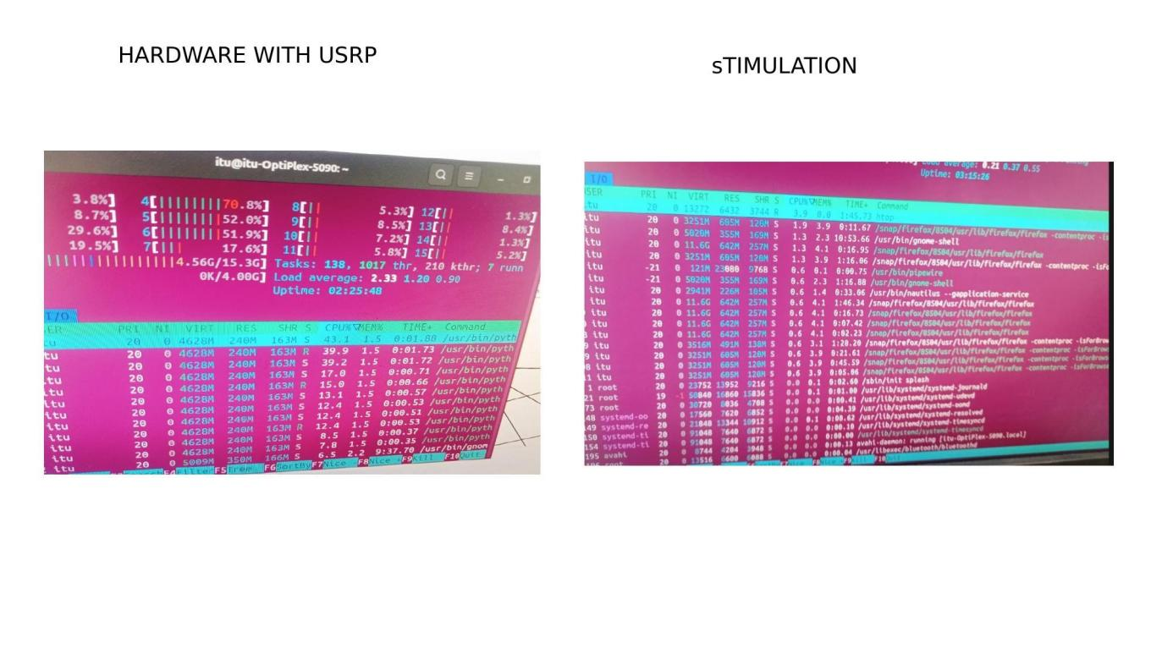

Purpose of This Check
This section exists to confirm, with real operating-system evidence, that the flowgraph was actually executing in parallel — not just configured to. The htop screenshots above show several cores simultaneously active at non-trivial load, rather than a single core pegged at 100% while the rest sit idle, which would indicate GNU Radio had silently fallen back to single-core scheduling.

Cores Used by Our Flowgraph
The flowgraph distributes its main processing stages across four dedicated CPU cores:
Core | Task in Our Flowgraph
Core 1 | USRP Source — receives raw RF/I-Q samples from the SDR
Core 2 | Multiply Const — amplifies/scales the incoming samples
Core 3 | Keep M in N — extracts the fixed-size packet/chunk from the stream
Core 4 | Stream Mux — recombines the processed chunks into one output stream

This is a pipeline, not just parallel chunks: each core works on a different stage of the same sample at the same time — Core 1 receives new samples while Core 3 extracts older packets and Core 4 combines already-finished ones. That overlap is what lets the system keep up with a continuous 15 MSps stream instead of stalling between stages.
The htop screenshots above are the proof of this concurrent pipeline. The Section 9 per-core table extends this picture to all 16 logical cores and shows the real imbalance: cores 4–6 (the Symbol Sync / Costas Loop chains) carried the heaviest load, while most other cores were nearly idle — meaning there is still headroom to assign more DSP blocks to unused cores, exactly the lesson Section 14's reference design (Miller's 8-core affinity table) demonstrates at a larger scale.

9. Per-Core CPU Utilization
Observed utilization across all 16 logical CPU cores during high data-rate processing:
CPU Core | Utilization (%) | Status
Core 0 | 3.8 | Low
Core 1 | 8.7 | Low
Core 2 | 29.6 | Moderate
Core 3 | 19.5 | Moderate
Core 4 | 70.8 | High
Core 5 | 52.0 | High
Core 6 | 51.9 | High
Core 7 | 17.6 | Moderate
Core 8 | ~2 | Low
Core 9 | ~5 | Low
Core 10 | ~7 | Low
Core 11 | 5.8 | Low
Core 12 | 1.3 | Low
Core 13 | 8.4 | Low
Core 14 | 1.3 | Low
Core 15 | 5.2 | Low

- A small subset of cores (4, 5, and 6) carried the highest load, confirming that the heaviest DSP blocks were concentrated on a few cores.
- Remaining cores operated at low-to-moderate utilization, indicating room for further load balancing.

10. Hardware Setup — USRP Connection
- The NI USRP-2901 was connected via SMA cables for transmit and receive paths, interfaced over USB 3.0.
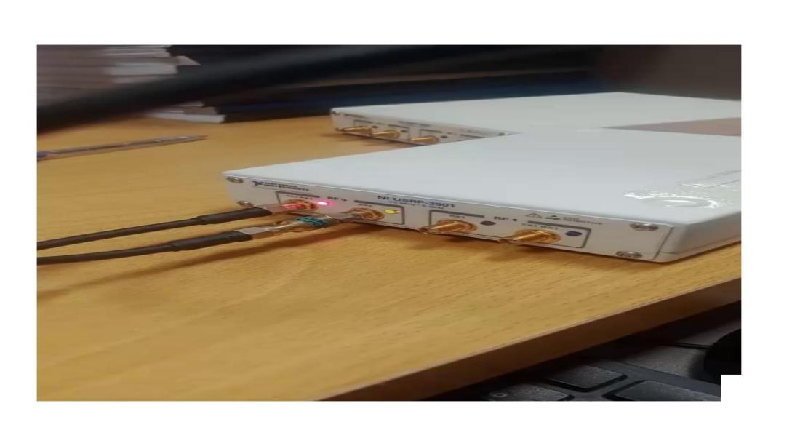

11. GNU Radio Flowgraph — Simulation Configuration
- The simulation flowgraph used a UHD: USRP Source/Sink, Multiply Const, Keep M in N, and Stream Mux blocks to replicate the chunk-based parallel processing chain.
- Sample rate was configured at 15 MSps with a center frequency of 80 MHz.
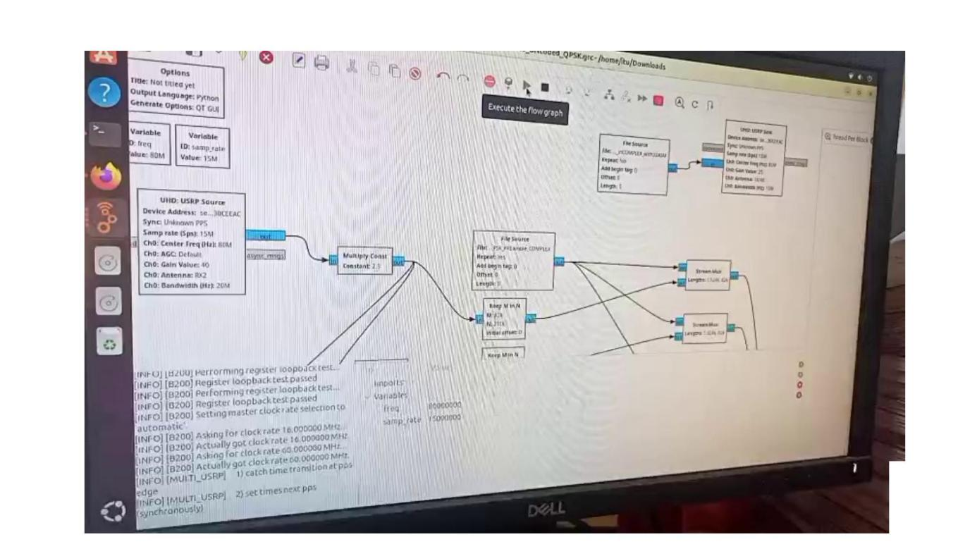

12. Simulation Output — Constellation Diagram
- The simulation (“SIMULATION_NO_LIMESDR_HighDataRate_UNcoded_QPSK”) was executed to verify correct signal flow before hardware deployment.
- The resulting I-Q constellation plot confirmed the expected QPSK phase clustering.
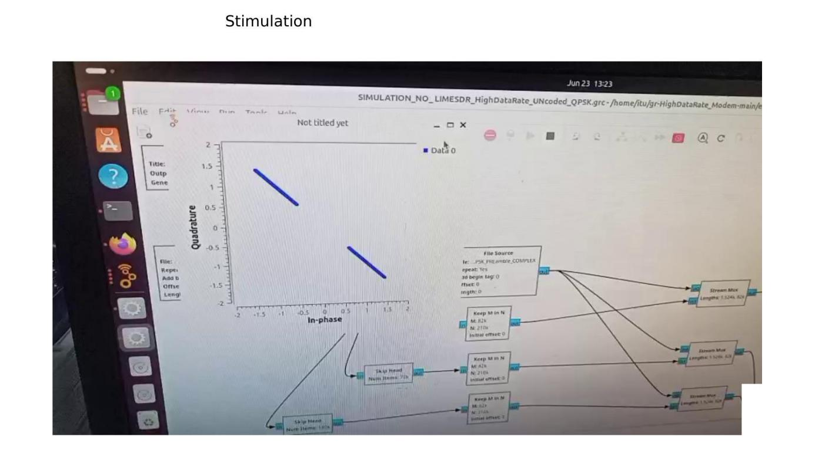

13. Hardware Execution — USRP Flowgraph
- The validated flowgraph (“HighDataRate_UNcoded_QPSK with accurate samples”) was executed on hardware using the USRP source and sink at 15 MSps.
- Terminal logs confirmed successful generation and execution of the compiled QPSK 15 Mbps processing chain.
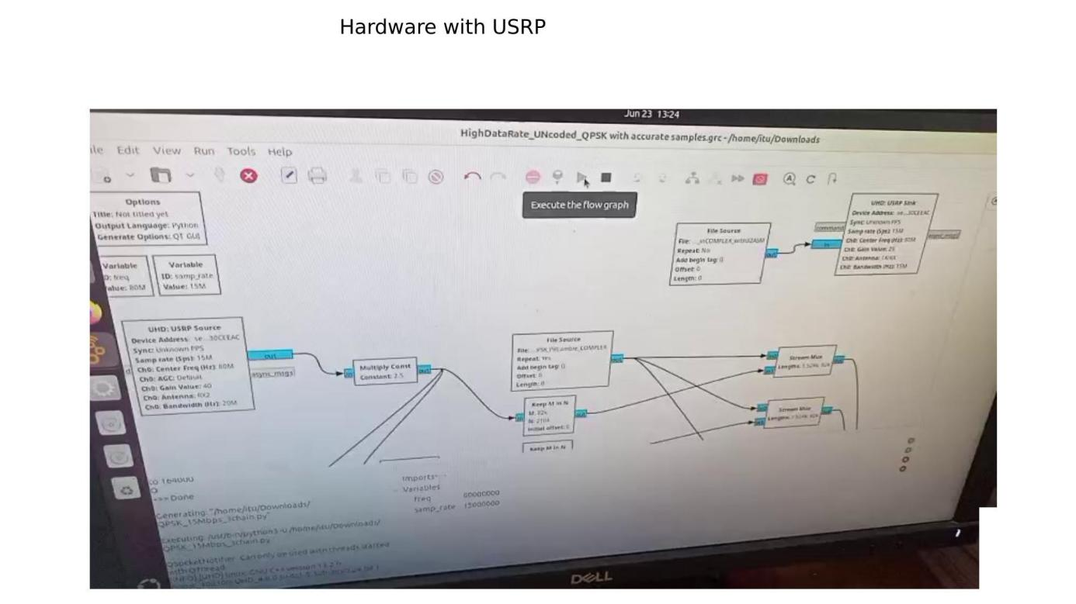

CPU Core
Flowgraph Block | Assigned Core
Test Modulator File Source Block | 1
LimeSuite Source (Receiver) | 1
LimeSuite Sink (Modulator) | 1
Front-End Skip and Multiplier Blocks | 2
Front-End “Keep M in N” and “Stream Mux” Blocks | 2
Front-End File Source (Preamble) Block | 2
Symbol Synchronizer / Costas Loop — Chunk Chain #1 | 4
Symbol Synchronizer / Costas Loop — Chunk Chain #2 | 5
Symbol Synchronizer / Costas Loop — Chunk Chain #3 | 6
“Complex To Float” Blocks | 4, 5, 6
“Binary Slicer” and “Interleave” Blocks | 7
“TAG_CHUNKpreamble” Blocks | 7
“Chunk_ExtractQPSK” Blocks | 7
Back-End “Stream Mux” Block | 3
Back-End “Keep M in N” Block | 3
“Tag_FrameASM” Block | 3
“Extract_Frame” Block | 3
“Resolve_Phase” Block | 3
Back-End File Sink Block | 3

Key Test Parameters
Parameter | Value
RF Center Frequency | 80.0 MHz
Sample Rate | 15.0 MSps
Symbol Sync Input | 2.0 samples/symbol
Symbol Sync Output | 1.0 sample/symbol
Costas Loop Order | 4 (QPSK)

Results:
- The demodulator recovered the transmitted frame stream with no bit errors, no missing frames, and no extra frames or bits.
- The 15.0 Mbps frame stream was successfully reassembled in real time from the three parallel chunk chains.
- Symbol Synchronizer and Costas Loop lock were continually re-established for every new chunk and chunk-preamble marker.
- Setting a high minimum output-multiple value for the custom blocks, so that each scheduler work-call processed 15–20 frames at a time, improved flowgraph throughput at high data rates.

